**MINI PROJECT REPORT**

**ON**

**“**CHILD VACCINATION MANAGEMENT SYSTEM**”**

**SUBMITTED IN PARTIAL FULLFILLMENT OF THE REQUIREMENTS OF DEGREE OF**

**BACHELOR OF ENGINEERING**

**BY**

**JAY KADAM**

**SAIRAJ AMBRALE**

**MANAS CHAUDHARI**

**SHREYAS BHUTKAR**

**SUPERVISOR**

**Mrs. Pradnya Patil**



**DEPARTMENT OF COMPUTER ENGINEERING**

**PILLAI HOC COLLEGE OF ENGINEERING AND TECHNOLOGY, PILLAI HOCL EDUCATIONAL CAMPUS, HOCL COLONY,**

**RASAYANI, TAL: KHALAPUR, DIST: RAIGAD, 410207**

**UNIVERSITY OF MUMBAI**

**[2023-24]**



**Mahatma Education Society’s**

**Pillai HOC College of Engineering and Technology,**

**Rasayani-410207**

**2023-24**

**Certificate**

This is to certify that the Mini Project entitled “**CHILD VACCINATION MANAGEMENT SYSTEM”** is a bonafide work of **Jay kadam, Sairaj Ambrale, Manas Chaudhari, Shreyas Bhutkar** submitted to the University of Mumbai in partial fulfilment of the requirement for the award of the degree of **“Undergraduate”** in **“Computer Engineering”.**

**_____________________ ________________________**

**Ms. Pradnya Patil Ms. Snehal Chitale**

(Guide) (Project Coordinator)

|  |  |
| --- | --- |
| **_____________________**  **Dr. Rajashree Gadhave**  (Head of Department) | **________________________**  **Dr. J. W. Bakal**  (Principal) |

**Mini Project Report Approval**

This project report entitled “**CHILD VACCINATION MANAGEMENT SYSTEM”** submittedby **“Jay kadam, Sairaj Ambrale, Manas Chaudhari, Shreyas Bhutkar”** is approved for the degree of **Bachelor of Engineering in Computer Engineering**.

**Examiners**

1.

2.

**Date**

**Place:**

**Declaration**

We declare that this written submission represents our ideas in our own words and where others ideas or words have been included. We have adequately cited and referenced the original sources. We also declare that we have adhered to all principles of academic honesty and integrity and have not misrepresented or fabricated or falsified any idea/data/fact/source in our submission. We understand that any violation of the above will because for disciplinary action by the Institute and can also evoke penal action from the sources which have thus not been properly cited or from whom proper permission has not been taken when needed.

|  |
| --- |
| **Jay kadam** |
| **Sairaj Ambrale** |
| **Manas Chaudhari**  **________________________ Shreyas Bhutkar** |

**Date:**

**Abstract**

The **Child Vaccination Management System** is a web-based platform designed to streamline the process of managing and scheduling child vaccinations. The system allows healthcare providers to track vaccination appointments, send automated reminders to parents, and store vaccination records efficiently. By integrating automated SMS reminders for upcoming appointments, the platform ensures that parents are well-informed about their child's vaccination schedules. This project addresses common issues such as missed vaccinations due to forgetfulness or lack of communication and proposes a more organized, accessible solution for healthcare providers and parents alike.

**List of Figures**

|  |  |  |
| --- | --- | --- |
| **Figure No.** | **Figure Name** | **Page No.** |
| Figure 4.1 | Graph : Plan of Project | 11 |
| Figure 4.2 | System Architecture | 12 |
| Figure 5.1 | Screenshot (a) | 17 |
| Figure 5.1 | Screenshot (b) | 18 |
|  |  |  |
|  |  |  |
|  |  |  |

**TABLE OF CONTENTS**

**Content Page No.**

**Abstract i**

**List of Figures ii**

**1. Introduction 1**

1.1 Features 3

**2. Literature Survey 4**

2.1 Basic Terminologies 5

2.2 Existing System 5

2.3 Problem Statement 6

**3. Requirement Gathering 7**

3.1 Software Requirements 9

**4. Plan of Project 10**

4.1 System Architecture 12

4.2 Methodology 13

**5. Result Analysis 15**

5.1 Results and discussion 17

**6. Conclusion 22**

**References 24**

**Chapter 01**

**Introduction**

**Chapter 1**

**Introduction**

The **Child Vaccination Management System** aims to address these challenges by providing an automated, web-based platform that simplifies the process of managing child vaccinations. It is designed to improve communication between healthcare providers and parents by sending timely reminders and maintaining a digital record of each child's vaccination history. The system will automatically notify parents of upcoming vaccination appointments via SMS, ensuring that they are well-informed and can plan accordingly.

The traditional system of manually tracking vaccinations, whether through paper records or spreadsheets, is prone to errors, mismanagement, and forgetfulness. Healthcare professionals often face difficulties in reminding parents about upcoming vaccinations, leading to missed appointments. Similarly, parents may lose track of their child's vaccination dates amidst busy schedules, which can result in delays in receiving critical vaccines. The lack of automated reminders and proper record-keeping often results in low vaccination coverage, leaving many children vulnerable to preventable diseases.

**1.1 Features**

Here's what you can expect from our App:

* Automated Appointment Scheduling: Allows users to schedule vaccination appointments and sends reminders two days before the appointment.
* User Authentication: Secure login system that only allows registered users to access vaccination records and appointment scheduling.
* Vaccination Records: Stores all vaccination details for easy access and reference.
* SMS Reminder System: Automatically sends reminders to parents before scheduled vaccination dates.
* Mobile and Responsive Design: The platform is accessible on various devices, providing convenience to users.

**Chapter 2**

**Literature Survey**

**Chapter 2**

**Literature Survey**

**2.1 Basic Terminologies**

* Vaccination: The process of administering a vaccine to a child to stimulate their immune system and protect against diseases. The system helps schedule and manage these vaccinations efficiently.
* SMS (Short Message Service): Used to send automated reminders to parents, notifying them of upcoming vaccination appointments, ensuring timely vaccinations for their children.
* User Authentication: Ensures that only authorized users (parents, healthcare providers) can access and manage vaccination records, ensuring data security.
* CRUD Operations: Basic database operations (Create, Read, Update, Delete) used in the system to manage appointments, vaccination records, and user data.
* API (Application Programming Interface): In this system, APIs like Textbelt are used to send SMS reminders, integrating third-party services into the application for seamless communication.

**2.2 Existing system**

Currently, many healthcare providers rely on manual methods to track vaccination schedules, which often leads to inefficiency and missed appointments. The existing systems lack automated notifications and easy access to records, which can cause delays in critical vaccinations.

**2.3 Problem Statement**

The manual tracking of vaccination schedules often leads to missed appointments due to poor communication or lack of reminders. This project aims to provide a solution by developing an automated system that sends SMS reminders to parents and stores vaccination records.

**Chapter 3**

**Requirement Gathering**

**Chapter 3**

**Requirement Gathering**

* **Healthcare Providers**: The primary users who can create and manage vaccination appointments, view and update child vaccination records.
* **Permissions**:
  + Add, edit, or delete vaccination appointments.
  + Access and manage vaccination records for each child.
  + Send SMS reminders for upcoming appointments.
* **Parents/Guardians**: Users who can view vaccination schedules for their children, receive SMS reminders, and track vaccination progress.
* **Permissions**:
  + View vaccination schedules and appointment history.
  + Receive SMS reminders for upcoming appointments.
* **System Administrators**: The user responsible for managing and monitoring the system's overall operations.
* **Permissions**:
  + Manage users (Healthcare Providers and Parents).
  + Oversee system health and manage settings.
  + Generate reports on vaccination statistics.

By gathering these requirements, the development team can create a detailed roadmap for designing, developing, and deploying the Quiz Master platform, meeting the needs and expectations of stakeholders effectively.

**3.1 Software and Hardware Requirements**

Here we will discuss everything we will need in order to execute. Below we list the necessary software requirements.

**Software Requirements:**

* **Web server (e.g., XAMPP)**
* **PHP**
* **MySQL Database**
* **HTML, CSS, JavaScript**

**2.Hardware Requirement**

* Computer
* Internet connection
* Mobile phones (for receiving SMS)

**Chapter 4**

**Plan of Project**

**Chapter 4**

**Plan of Project**

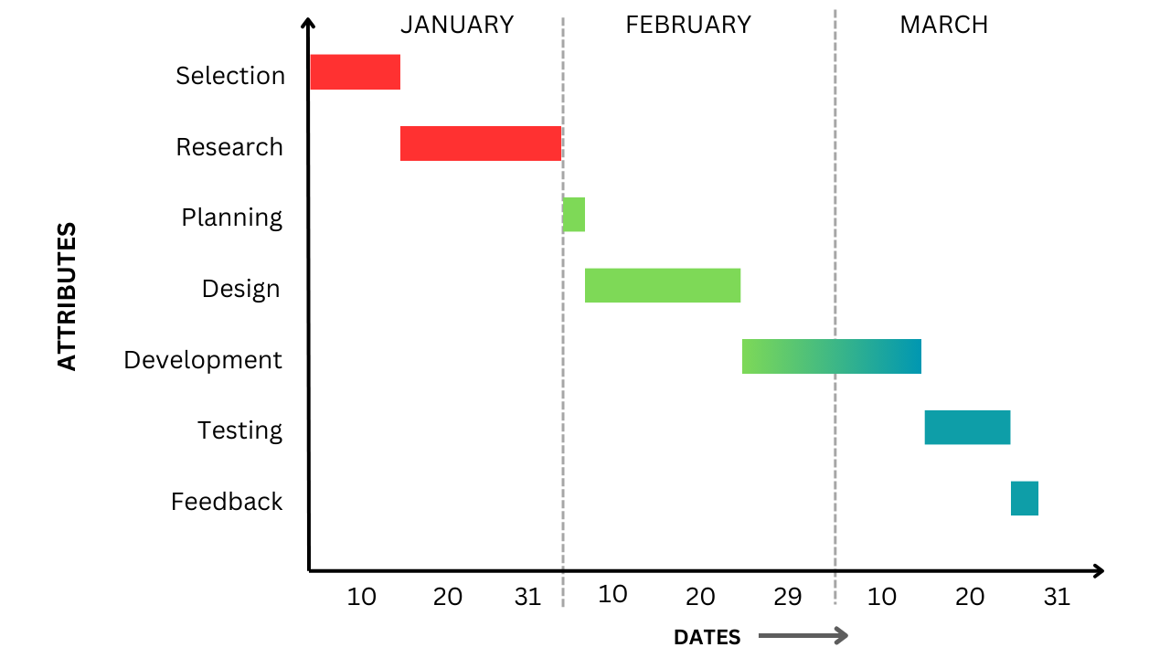

October

September

August

***Figure 4.1: Graph :Plan of Project***

**4.1 System Architecture**

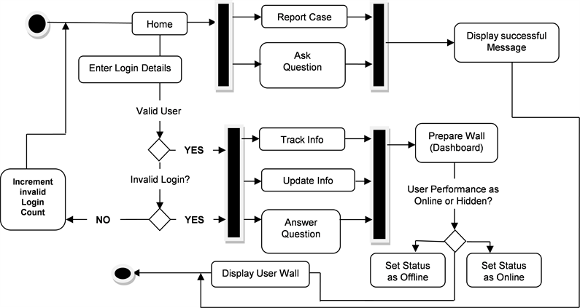

*Figure 4.2: System Architecture*

**4.2 Methodology:**

**Requirement Analysis**

* **Stakeholder Identification**: Identify the key stakeholders, including parents, healthcare providers, administrators, and government agencies.
* **User Requirement Gathering**: Conduct interviews or surveys to collect the functional and non-functional requirements of the system. Determine what features users expect (e.g., appointment scheduling, reminders, vaccination history).

**3. Technology Selection**

* **Frontend Technologies**: Select technologies like HTML, CSS, JavaScript (or a framework like React, Vue.js) for the user interface.
* **Backend Technologies**: Choose PHP, Python, or Node.js to build the server-side logic.
* **Database**: Use MySQL or another relational database to store user information, appointment schedules, and vaccination history.
* **Third-Party Services**: Decide on an SMS API provider (TextBelt, Twilio) for sending appointment reminders.

**4. Implementation**

* **User Authentication Module**: Develop the login and sign-up functionality using PHP and integrate user roles (admin, parents).
* **Appointment Scheduling Module**: Create a system that allows users to book and reschedule appointments.
* **SMS Reminder System**: Implement the API integration with TextBelt or Twilio to send SMS reminders to users.

**5. Testing**

* **Unit Testing**: Test individual components such as user authentication, scheduling, and SMS sending functionality.
* **Integration Testing**: Test the interaction between different components (e.g., between the frontend, backend, and database).
* **User Acceptance Testing (UAT)**: Conduct UAT with a small group of real users to gather feedback on the functionality and usability of the system.
* **Performance Testing**: Ensure the system performs well under load, especially when sending multiple SMS reminders.

**6. Deployment**

* **Server Setup**: Configure the web server (Apache or Nginx) to host the application.
* **Database Setup**: Deploy the MySQL database and ensure it is properly secured.

**Chapter 5**

**Result Analysis**

**Chapter 5**

**Result Analysis**

The implementation of the **Child Vaccination Management System** has yielded significant results, creating a robust and user-friendly platform designed to simplify vaccination scheduling and reminders for parents and healthcare providers. The system has significantly improved **user engagement** among parents, who appreciate timely SMS reminders for upcoming vaccinations, ensuring they stay on top of their child’s immunization schedule. Healthcare providers have praised the platform’s intuitive interface, which makes it easy to manage vaccination records, schedule appointments, and send automatic reminders.

Moreover, the platform’s focus on **security** and **data protection** has built trust among users, ensuring that sensitive information is handled with care and compliance with privacy standards. By prioritizing **accessibility** and **ease of use**, the system has been well-received by users of varying technical proficiency, expanding its reach and usability. Additionally, the system has demonstrated excellent **scalability**, efficiently handling high volumes of appointments and reminders without compromising performance. Feedback from parents and healthcare providers alike indicates a strong preference for this solution, citing its effectiveness in reducing missed appointments and ensuring timely vaccinations.

**5.1 Results and Discussion**

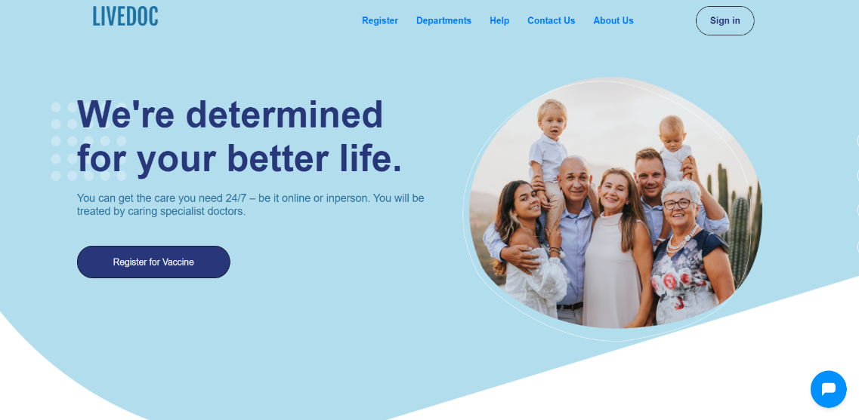 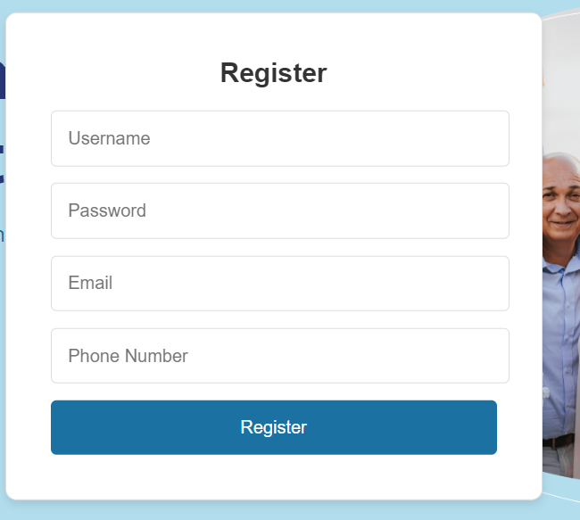

*Figure 5.1: Screenshot (a)*

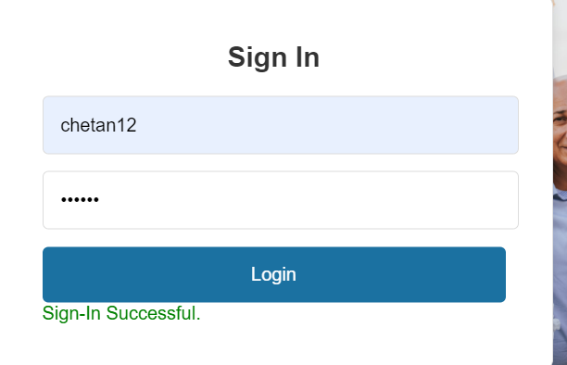 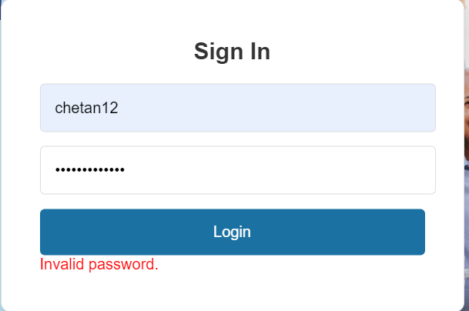

*Figure 5.2: Screenshot (b)*

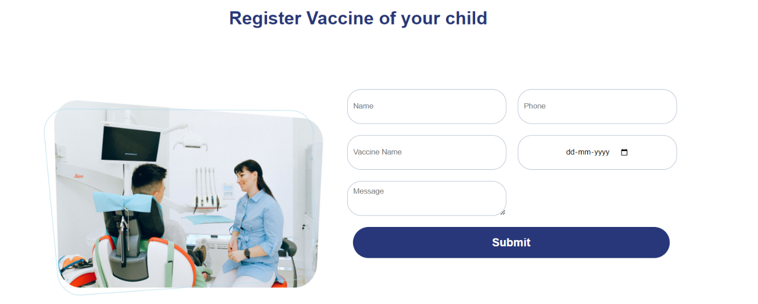

*Figure 5.2: Screenshot (c)*

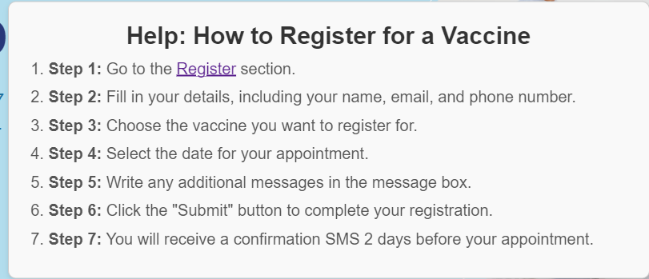

*Figure 5.2: Screenshot (d)*

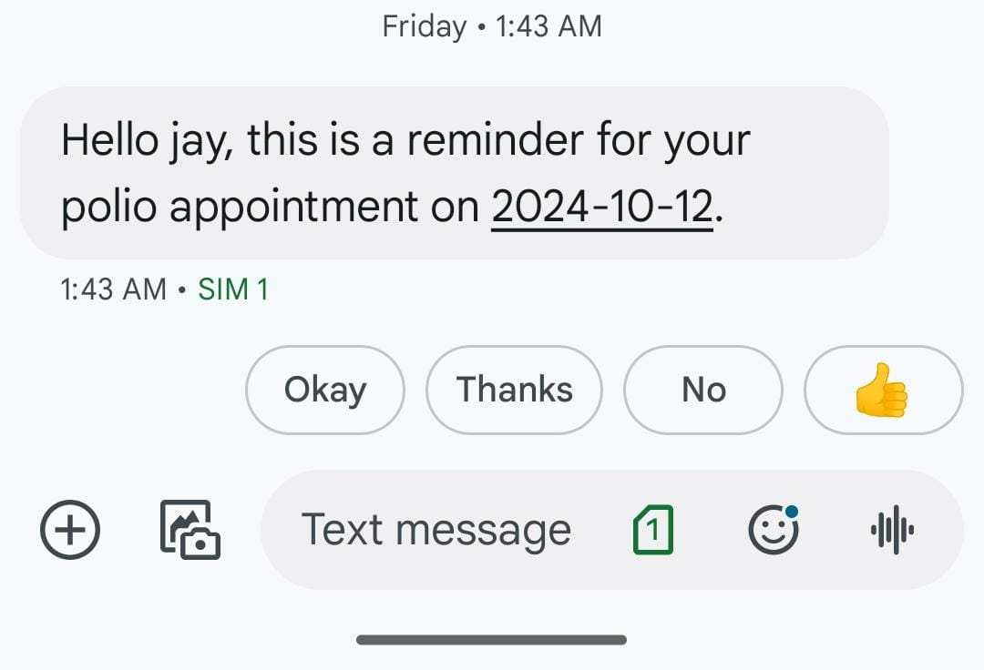

*Figure 5.2: Screenshot (e)*

**Chapter 6**

**Conclusion**

**Chapter 6**

**Conclusion**

The development and deployment of the **Child Vaccination Management System** have proven to be a significant step forward in streamlining and enhancing the vaccination process for children. The system successfully addresses the challenges of missed appointments and inefficient scheduling by automating reminders and providing a user-friendly interface for both parents and healthcare providers.

With its strong focus on **data security**, **usability**, and **scalability**, the platform has demonstrated reliability and adaptability in various settings, ensuring that it can accommodate increasing user demands. The positive feedback from both users and stakeholders highlights its effectiveness in improving vaccination compliance, thereby contributing to better public health outcomes.

In conclusion, the **Child Vaccination Management System** not only simplifies the vaccination tracking process but also ensures that children receive timely vaccinations, fostering a healthier future for communities. Its success paves the way for potential expansions and enhancements that can further increase its impact in the healthcare sector.

**References**

* World Health Organization (WHO). "Vaccines and Immunization." <https://www.who.int/health-topics/vaccines-and-immunization>
* Centers for Disease Control and Prevention (CDC). "Childhood Vaccines." <https://www.cdc.gov/vaccines/parents/childhood-vaccines/index.html>
* UNICEF. "Immunization." https://www.unicef.org/immunization
* Global Vaccine Action Plan 2011-2020. World Health Organization. <https://www.who.int/publications/i/item/global-vaccine-action-plan-2011-2020>
* ChatGPT, OpenAI (2024). "Child Vaccination Management System: Project Guidance and References." Available upon request.